Aim: Study of various wireless communication technology like IEEE 802.15.1, IEEE 802.15.4 and IEEE 802.11

Software Requirements:
- Windows or Linux Desktop Operating System
- Arduino IDE

Objectives:
- To understand the working principles of different types of sensors.
- To study real-world applications of sensors in various industries.
- To learn how to select a suitable sensor for a given application.

Prerequisite:
- Basic knowledge of electronics and measurement systems.
- Familiarity with physical parameters like temperature, pressure, light, motion, etc.
- Understanding of analog and digital signal concepts.
- Awareness of common electronic components and circuits.

IEEE 802.15.1 (Bluetooth)
First standardized in 2002, it defines a Wireless Personal Area Network (WPAN) for short-range, low-power communication primarily for connecting peripheral devices. It operates in the 2.4 GHz ISM band and uses frequency-hopping spread spectrum (FHSS) to mitigate interference.

Features:
- Simple Pairing: Designed for easy, secure connection between devices like headphones, keyboards, and phones.
- Low Power Consumption: Especially with its Bluetooth Low Energy (BLE) mode, enabling long battery life for small devices.
- Ubiquitous Integration: Built into virtually every smartphone, tablet, laptop, and countless IoT devices.

Drawbacks:
- Limited Range: Typically, effective only within a 10-meter radius (Class 2 devices).
- Relatively Low Data Rate: While improved, its maximum data rate is far lower than Wi-Fi, making it unsuitable for high-bandwidth tasks.
- Interference Prone: Operates in the crowded 2.4 GHz band, which can lead to performance drops near other Wi-Fi or Bluetooth devices.

Applications:
- Wireless audio streaming (headphones, speakers).
- Hands-free calling in vehicles.
- Connecting input/output devices (mice, keyboards, printers).

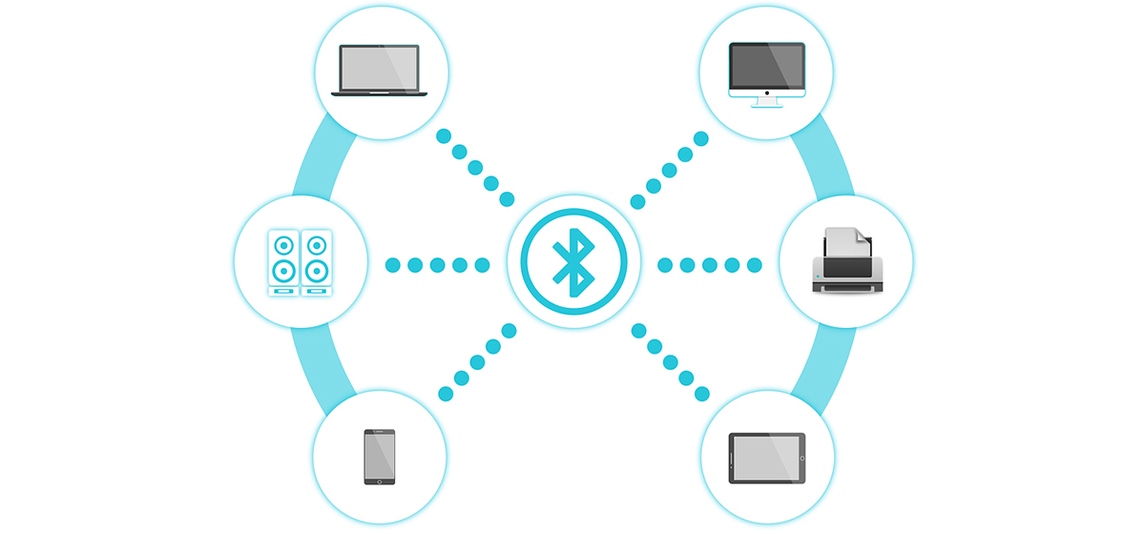

IEEE 802.15.4 (Zigbee, Thread, 6LoWPAN)
Standardized in 2003, it is the foundational protocol for low-rate wireless personal area networks (LR-WPANs), focusing on very low power, low data rate, and low-cost communication. It forms the physical and link layer for protocols like Zigbee and Thread, operating in the 2.4 GHz, 900 MHz, and 868 MHz bands.

Features:
- Extremely Low Power: Devices can run for years on small batteries due to simple protocol stacks and long sleep cycles.
- Mesh Networking: Supports robust, self-healing mesh topologies that extend network range and reliability.
- High Scalability: Networks can support a large number of nodes (theoretically over 65,000), ideal for dense sensor deployments.

Drawbacks:
- Very Low Data Rate: Designed for intermittent, small packets of data (e.g., sensor readings), not for audio/video.
- Low Latency but Not Guaranteed: While generally responsive, it does not guarantee deterministic latency like wired industrial networks.
Applications:
- Home and building automation (smart lighting, thermostats, sensors).
- Industrial sensor networks and process monitoring.
- Agricultural sensor networks and asset tracking.

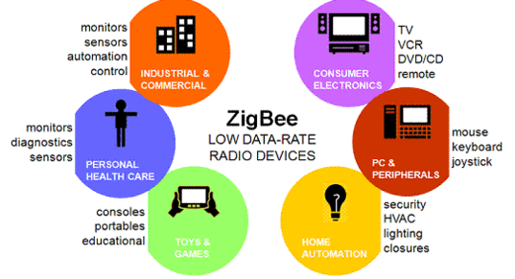

IEEE 802.11 (Wi-Fi)
First released in 1997, it defines the standards for Wireless Local Area Networks (WLANs), providing high-speed internet and network access over moderate distances. It has evolved through generations (e.g., 802.11a/b/g/n/ac/ax) to offer dramatically increased speed, range, and efficiency, primarily in the 2.4 GHz and 5 GHz bands.

Features:
- High Data Throughput: Modern Wi-Fi 6/6E/7 offers multi-gigabit speeds, supporting data-intensive applications like video streaming and gaming.
- Wide Area Coverage: Routers can provide coverage throughout a home or office, with extenders and mesh systems increasing the range further.
- Seamless Internet Access: The primary technology for untethered broadband internet connectivity to laptops, phones, and smart home devices.

Drawbacks:
- High Power Consumption: Requires significant power, making it unsuitable for most battery-operated IoT sensors.
- Network Congestion: Performance degrades in dense environments with many competing networks and devices.

Applications:
- General internet access in homes, offices, and public hotspots.
- Wireless media distribution (smart TVs, streaming boxes).
- Local wireless networking for printers, file servers, and video surveillance systems.

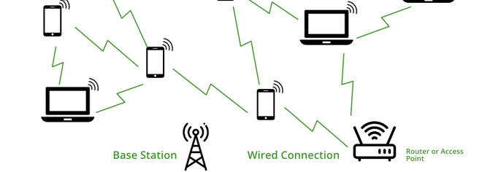

Comparison:
Feature | IEEE 802.15.1 (Bluetooth) | IEEE 802.15.4 (Zigbee/Thread) | IEEE 802.11 (Wi-Fi)
Primary Purpose | Cable replacement for peripherals; personal area connectivity | Low-power sensor networks; industrial & home automation | Wireless local area networking; internet access
Year | 2002 (v1.1) | 2003 | 1997 (initial standard)
Typical Range | 1–10 meters (up to 100m with Class 1) | 10–100 meters (extended via mesh) | 30–100 meters (indoor)
Data Rate | Slowest | Moderate | Fastest
Power | Low (very low with BLE) | Extremely Low | High
Topology | Star and scatternet | Mesh, star, cluster tree | Star and ad-hoc
Applications | Audio streaming, input devices, file transfer | Smart lighting, industrial sensors, etc | Internet access, video streaming, office networks
Key Advantage | Ubiquity & ease of pairing | Ultra-low power & large-scale mesh networking | High throughput & seamless internet connectivity

Conclusion
Successfully observed how each wireless communication technology serves a specific purpose. Bluetooth is ideal for short-range personal device communication. Zigbee is best suited for low-power sensor networks and IoT applications due to its mesh topology and scalability. WiFi, with its high data rate and wide usage, is preferred for high-speed internet access and multimedia applications.

